Fungi, Vascular and Non-vascular Plants.
Name:
Course:
Institution:
Instructor:
Date:

AIM
To examine the anatomy and life cycle of basidiomycetes fungi, mosses, and ferns.
To explore the diversity of lichen forms.
INTRODUCTION.
Kingdom fungi compromise of diverse group of multi-cellular organisms which are heterotrophic. They include mushrooms, mildews and yeast. Members of this kingdom have diverse nutrition modes and thus occupy varying habitats. They feed by releasing digestive enzymes in organic matter and absorbing nutrients. Some fungi are parasites of plants, Protista, animals and even other fungi and others groups of fungi are saprophytes who feed on decomposing organic matter. Other fungi species such mycorrhizas and lichens have complex symbiotic relationship with photosynthetic organisms (Stern et al, 2000).
Most fungi reproduce through both sexual and asexual reproduction methods. Reproduction begins with asexual phase which can occur in two ways; fragmentation and sporulation. When fungi fragment the newly formed fragments develops to become new fungi. During sporulation structures known as sporangia are formed. When a sporangium matures, it disintegrates releasing spores in air. When they land in a medium with suitable germinating condition, they form new bodies of hyphae. In sexual reproduction, two specialized hyphae unite to form gametangia. Inside the gametangia a zygote is developed and new fungus develop inside the zygote.
Fungi have only a single division known as Eumycota. The division has four classes classified according to their cellular features and the mode of reproduction. The classes are zygomycetes which live on organic matter and reproduce asexually by sporulation, ascomycetes that include edible mushrooms, basidiomycetes, and deuteromycetes (Hibbett et.al, 2007).
In this experiment, I examined the anatomy and life cycle of mushrooms, mosses, and ferns and explored the diversity of lichen forms. I expected to find basidiomycetes fungi, mosses and ferns at different growth stages. I also expected to see various types of lichens during the experiment.
APPARATUS AND MATERIALS
Razor blade
Camera
Basidiomycetes mushroom
Moss
Lichens
Phone with internet access.
PROCEDURE
Experiment 1: Mushroom.
Using a razor blade, I sliced the mushroom into two halves. I identified the parts of the mushroom and placed the mushroom in a well-lit platform and took a photo. Using the parts I determined the ploidy and checked on the presence of spores.
Experiment 2: Mosses.
I collected the moss from the bark of tree and rehydrated them by sprinkling water on them. I transferred the collected moss and placed them a clean platform and took a photo.
Experiment 3: Horsetails
I watched the video made from Harris State Beach in southern Oregon - http://youtu.be/n8fNnQM9vVc and checked for presence of leaves and their differences with other plants. I also checked to determine the life cycle of horsetails in the video.
Experiment 4: Ferns.
Using the video link, I observed the licorice ferns, a cool fern species on the coast of Oregon which can grow as a lush epiphyte – plants that grow harmlessly on other plants while extracting nutrients and water from the air or from deposits on other plants. It can also grow from the cracks of massive rocks right in the tidal zone. I checked for the presence of sori and their location in ferns. I also checked for other organisms growing alongside the fern. The video link is: https://www.youtube.com/watch?v=8-TH0bQ7Q3o
Experiment 5: Lichens
I collected lichens from barks of trees and took them in a well-lit platform and took a photo. Identified the lichens collected from the rock outcrops.
RESULTS
The mushrooms were filamentous with hyphae. They were non vascular. Basidia cells were not distinctively identified.
The mosses were small flowerless plants. They were in the gametophyte stage. The turned bright after sprinkling with water.
Horsetails in the video were herbaceous stems. The stems had internodes and nodes. They are in gametophyte stage. The have small scaly leaves attached to the nodes.
The ferns have vascular stem which is branched. Lichens are observed as the video begin. They have sori on the underside of frond.
Lichens are green in color. Two types are observed in the experiment.
DISCUSSION
Questions.
- Mushroom
- What is the ploidy of the basidiocarp? Check out the life cycle of basidiomycetes on page 647 of your text if you are unsure.
A basidiocarp is dikaryotic composed of two haploid mycelia nuclei fused together through the process of plasmogamy. Since karyogamy is delayed, the fused mycelia remain as a pair and hence the dikaryotic ploidy.
- Where are the spores created in the basidiocarp and what is the structure they are attached to called?
Spores created in the basidiocarp and are known as basidiospores and are attached to structures known to as basidia. Basidiospores are attached to Basidium by a hillar appendage.
- Through which process of cell division are the spores created? What is their ploidy?
Basidiospores are created from specialized cells of basidia through the process of meiosis and are haploid cells.
- Mosses
- What is the ploidy of the sporophyte? The gametophyte?
The sporophyte is diploid while the gametophyte is haploid.
- Even though some moss can grow in dry habitats, why do they still need water for reproduction (look back at figure 29.8)?
The process of fertilization is dependent on water availability. When the water is present the sperms from antheridia which have two flagella swim to archegonia where fertilization occurs and a diploid sporophyte is formed.
- Horsetails.
- Does the horsetail in the video have leaves? How are they different from other plants?
The horsetails in the video do not have leaves. Unlike other plants the horsetails are elevated stems with internodes and nodes. They are succulent and are greener than the surrounding plants.
- What life cycle stage do you think this is – sporophyte of gametophyte? Why – what structures seen in the video lead you to this conclusion?
The horsetails are in the sporophyte phase. The stems have elevated cones where spores are formed and later dispersed by wind.
- Ferns.
- What are sori – what do they contain?
Sori are clustered sporangia that contain spores and found on the underside of a sporophyll leaf (frond) of a fern.
- Why might sori be located on the underside of the sporophylls?
Ferns depend on presence of water to carry out fertilization process. Presence of sori on the underside of sporophylls increases the chances of fertilization as water does not rapidly evaporate on the underside of the sporophyll as compared to the topside.
- What is most of the “green stuff” on the log in the beginning? What is the most significant difference between it and the ferns growing nearby?
The lichens are growing on the log. Unlike the ferns, the lichens do not have a vascular stem and are attached to the substrate (log). Ferns are elevated and have branched stems.
The mushroom was filamentous and contained hyphae. The mode of reproduction is sexual and happens in structure called basidia. Basidium is formed by fusion of two spores. After the fusion a binucleate hyphae is formed with diploid cells (Stern et al, 2000). The basidia cells undergo meiosis to form four haploid cells mature to form spores.
The mosses are small flowerless plants found growing on moist rock and shady places. The mosses observed during the experiment were in the gametophyte phase. Mosses reproduce using spores. The gametophytes are diploid while the sporocytes are haploid. Although mosses can grow in dry habitats they need water for reproduction to occur. They also need water for other life sustaining processes such as growth.
The horsetail observe in the video is a herbaceous plant with elevated stems which have nodes and internodes. They are vascular plants (Hibbett et.al, 2007). The horsetail was in gametophyte stage. They have scale like leaves attached to the nodes. The have rhizoids which anchor them to the soil. It is a non-flowering plant and reproduces by use of spores. The cells of horsetails are diploid.
Ferns observed in the video are vascularized plants with branched stems. The fern is in sporophyte phase which is the dominant form. There are lichens which are green besides the ferns when the video starts. The leaf of a fern is known as a frond. There are two types of fronds, a trophophyll which carries out photosynthesis and a sporophyll which carries out reproduction. A fertile sporophyll contains spores in the sporangia. The sporangia are found on the underside of the sporophyll and are clustered to form sori. The reproduction of ferns depends on presence of water and as a result sori are found in underside of frond (Cobb et al, 2005).
Lichens are green complex life forms that a symbiotic relationship of a fungus and an alga. The dominant partner in the association is the fungus. There are three types of lichens crustose, foliose and fructicose. Crustose lichens are flat and have no lobes. Foliose lichens are circular and have lobes. Fructicose lichens have branches growing vertically and have no rhizomes (Brodo et.al, 2001).
CONCLUSION
I was able to observe basidiomycetes mushroom morphology and determine the stage of its life cycle. The process was also successful for mosses, horsetails and ferns. I was also able to explore the diversity of lichens. The only challenge faced was locating the reproductive parts of the mushroom and walking long distance to locate the lichens.

References
Brodo, I. M., Sharnoff, S. D., & Sharnoff, S. (2001). Lichens of north America. Yale University Press.
Cobb, B., Farnsworth, E., & Lowe, C. (2005). A field guide to ferns and their related families: Northeastern and Central North America (Vol. 2). Houghton Mifflin Harcourt.
Hibbett, D. S., Binder, M., Bischoff, J. F., Blackwell, M., Cannon, P. F., Eriksson, O. E., & Lumbsch, H. T. (2007). A higher-level phylogenetic classification of the Fungi. Mycological research, 111(5), 509-547.
Stern, K. R., Bidlack, J. E., Jansky, S., & Uno, G. (2000). Introductory plant biology (Vol. 8). McGraw-Hill.
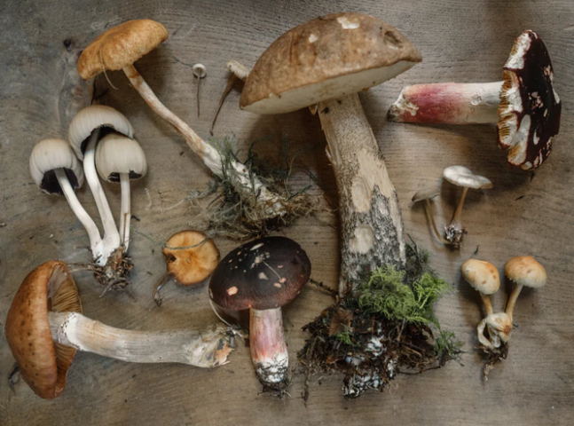
Mushrooms.
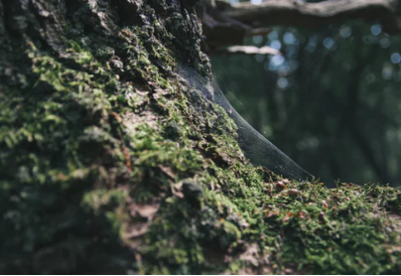
Mosses

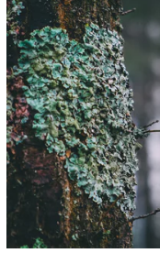
Foliose lichens.
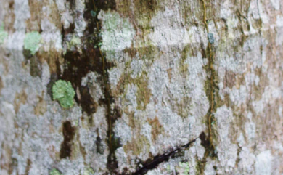
Crustose lichens

